**TRANSFORMATIONS-Translations Investigations**

Graph the base function and then each related function using Desmos. Use a different colour to help distinguish each function.

|  |  |
| --- | --- |
| **Recall:** If a number is added to or subtracted from a function, what happens?  f(x) = x2 | |
| g(x) = x2 + 3  h(x) = x2 - 5 | **Recall:** If a number is added to or subtracted from *x*, what happens?  For example, what transformations are applied to the graph of y = x2 to get y = (x - 2)2 |

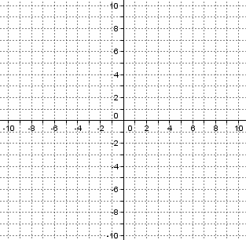



**SUMMARY**

f(x) + c moves the graph of f(x) ___________________________.

f(x - d) moves the graph of f(x) _______________________________  
f(-x) makes the graph of f(x) ____________________  
-f(x) makes the graph of f(x) ___________________

**TRANSFORMATIONS-Stretches & Compressions Investigations**

|  |  |
| --- | --- |
| **Recall:** If a function is multiplied by a value, what happens or x multiplied by a value?  y = x2  y = (2x)2  y = (0.5x)2 | |
| Look at the graphs of y = 2x2 and y = (2x)2. Why are they not the same? How could you describe the difference?  Describe the difference in the graphs above. Use the words horizontal & vertical along with stretch & compressed for each set of graphs. |  |

# Combining Translations, and Stretches

1. f(x) = 2+ 1 is a translation of g(x) = .

Sketch the base function 1st, then apply

the vertical stretch, and then …

Describe the translations

_______________________________

_______________________________