Database: Review Activity

Data can be retrieved quickly and accurately if the user has the necessary database skills.

Goal: Show you are able to sort and filter data effectively.
Create queries, reports, and forms that would be useful to others.

Success Criteria: I will be able to show I can do the following…
- Sort (to find alphabetically or numerically first and last items)
- Filter (to find answers to questions, using the advanced filter features)
- Make Reports, Forms and Queries

How to get the file if you don’t have it: (First copy the file to your h:drive workspace)

- Go to the Common Folder Armstrong Pick Up BTA Cooking Practice
- Copy the file and paste it into your folder.
- Rename the file your name cooking practice (do not delete the .accdb)
- Open the file; and Enable the file
- Under the Object List on the left side select the Products Table table

Part A: Using a Database

Using the Sort, or Filter methods, answer the following questions:

- How many records are in this database? ________
- How many field names are there? ___________
- What different data types are being used? _______________________________________
- What should be fixed about the “product name” field type?
5. Which dessert is alphabetically last? ______________________

6. What is the description given to Snickerdoodle?

7. How many products start with the work Apple? _________

8. How many Product Names contain the word “Chocolate”? _________

What search criteria did you use to get this information? ______________

9. How many Product Names end with the word “Cream”? _________

What criteria did you use to get this information? ______________
10. Which field is the primary key? Why would you use a primary key?

Part B: Creating a Database

1. Copy the file named test practice.mdb from the Students CommonArmstrongPickUpBTA
folder and paste it in your folder.

2. Rename the file your name test practice.mdb.

3. Open the database in Microsoft Access.

4. This is a database of Ricky Riordon books with fields about the book title, release date,
price etc.
When the database was created not all of the fields were made the correct type. The 2
fields that should be fixed are _______________ and ___________ . Fix them.

5. Add a field named Only in paperback that will be checked if the book only comes in
paperback. Place checks in the applicable boxes.

6. Add the following books

7. Sort the database by release date showing the oldest book 1st.

8. Do a filter to see how many books are . Toggle the filter to show the books that are best
sellers under $12. Temporarily remove the filter to see the whole list again. (do not clear it)

9. Create a Report of the table that includes the Book Title, release date and whether it was a
best seller. Have the report sorted by title in ascending order. Remember to change the
report title.

10. Create a Query of the table. The criteria for the query should display all of
those Greek books that are not on the best seller list. Have the query
display the book title as well.

11. Create a Report of the Query created in #10. Have it display the book titles and prices.
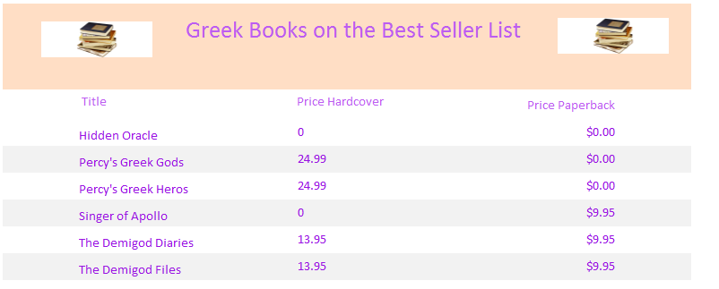
Sample Report

